Name: ________________________ Date: _________________

Explore 1: Ground Temperature vs. Air Temperature Activity
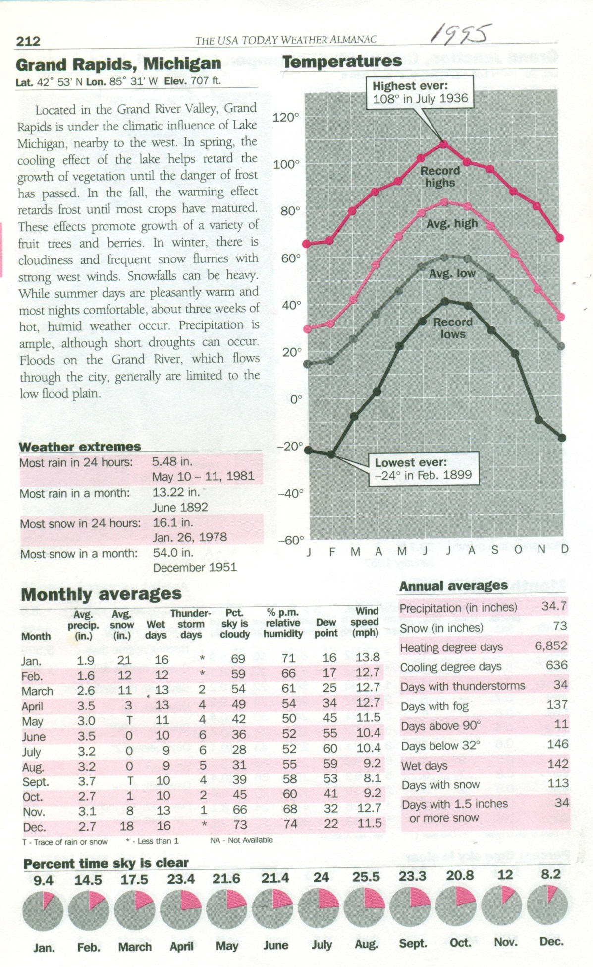

Figure 1. Weather Information for Grand Rapids, MI.
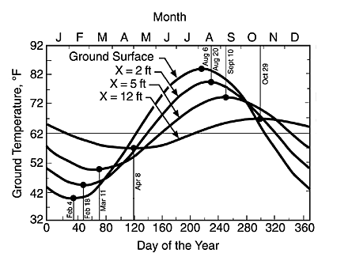

Figure 2. Seasonal soil temperature change as a function of depth below ground surface for an average moist soil.

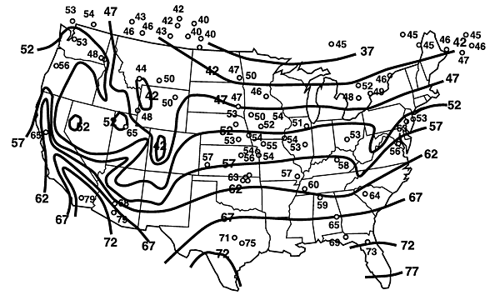

Figure 3. Mean annual earth temperature observations at individual stations, superimposed on well-water temperature contours.
Questions:

1. Looking at the average temperatures for the Grand Rapids area in Figure 1, what are the average low and high temperatures during the months of July and January?

2. Using Figure 2, what happens to the ground temperature as you increase depth during the summer months (List the specific temperature for 12ft)? What about the winter months (List the specific temperature for 12ft)?

3. Looking at this contoured map (Figure 3), what is the estimated mean annual ground temperature for Grand Rapids?

4. After looking at both air and ground temperatures during summer and winter, how do they vary in relation to each other during the year?

Elaborate 2: LEED Standards WebQuest

Visit the U.S. Green Building Council website. (http://www.usgbc.org) Follow the various steps and answer the questions below.

1. On the very top of the webpage, click “LEED”. Scroll down and read the information under the title, “Overview” (This title is on the left hand side of the webpage). Stop reading once you see the sentence “LEED v4 is the newest version…”

Answer the following questions:
- What does LEED stand for?

- Give a brief description of LEED

2. Scroll down until you reach the title, “Rating Systems” and read the information. Click on the five rating systems and answer the following question:
- Name at least three specific projects that are rated by LEED (Examples are New Construction, Retail, Data Centers, etc.)

3. Continue on the webpage and scroll to the title, “Credits”.
- List three credit categories.

4. Again, on the very top of the webpage, click “LEED”. Scroll down and find the “Levels of Certification” title.
- What are the four levels of certification for LEED and how many points are needed for each?

5. Continue on the same page and find the title “Why LEED?”
Answer the following questions:
- What does LEED try to accomplish for sustainability in buildings? (Under the title “Proven performance”)

6. Go to the top of the webpage and hit “Directory” on the right hand side. Click on “Browse” under Projects. Then click on LEED BD+C: Schools on the left hand side of the webpage. Use the filter in the middle of the page and click on “Name”. This should bring up a down drop of options, click on “State”. Then, in the blank box to the right of the down drop, type in “Michigan” and then hit “Apply”. Choose any school and answer the following questions:
- For the school of your choice, what is the certification level based on the points earned?

- Pick one category off of the building’s scorecard. List the category name and write down how many points that school has earned for that particular category.

7. Towards the top of the page, hit on the “Projects” Tab and in the search engine, type in Blandford School. Click on the link and answer the following question:
- What does the scorecard say for Blandford?

